**SOP FOR**

1. **PURPOSE: Safe maintenance of Lower seal & Upper Seal valve maintenance.**
2. **SCOPE: BLT manual and drawing**.
3. **RESPONSIBILITY: Engineer In charge & Maintenance Fitter on job.**
4. **PROCEDURE: Upper & Lower Seal valve Maintenance.**

PPE –s to be used :

* Helmet, Co monitor, dust mask Safety shoes, hand gloves and complete sealed goggle

LIST OF TASKS COVERED

Work No 1 : Upper/Lower seal valve plate replacement.

Work No 2 : Upper/lower sealing valve hydraulic cylinder replacement

Work No 3 : Upper seal burden shut off valve hydraulic cylinder replacement.

Work no 4 : Upper/Lower seal valve plate seal replacement

Work no 5: Upper/Lower seal valve plate seal cleaning

Aspect- Impact

|  |  |
| --- | --- |
| Scrap generation | Resource Depletion |
| Oil & Grease spillage | Land contamination & Resource Depletion |
| Fumes | Health |

Hazards identified

### Mechanical hazard - Fall of flange, bolts, wedges, rod etc.

### Fall of person due to grease & oil spillage on platform

### Impact with structure due to lower head room.

### Spillage of oil into the eyes while handling Oil.

Burden slip and subsequent gas, hot flame etc

Physical Hazard Explosion, Fire, Temperature, Pressure

Chemical Hazard - Gas poisoning.

Electrical Electric shock.

Behavioral Hazards: working without all required PPE’s

Working under influence of alcohol

Horse play

Casual approach

Not following SOP/WI while carrying out the job.

1. Note: Take electrical shutdown of power pack and isolate the shutoff valves inlet and outlet by keeping authorized fitter or engineer at power pack so that before & after isolation can be taken care. workmen (those who are involved in maintenance jobs) need not required to go everytime to power pack room to put/remove the individual isolation locks as equipmets are on top platform & powerpack is at bottom platform.

**Work No 1 : Upper seal & lower seal valve plate replacement**

1. Take clearance from control room in charge for working at furnace top by taking work permit.
2. Ensure Burden tank and receiving hopper to be emptied before taking for maintenance.
3. Top hatch to be opened as per WI /BF3/04.
4. Top firing is carried out by operation and ensure that, in that time period no workmen will be allowed to work in Tuyere platform.
5. Continuous co-ordination to be ensured with Operation dept.
6. Do carry 2nos CO detector and monitor it continuously.
7. Connect a 2 T chain block to the inspection door.
8. Job to be carried out in furnace shutdown
9. Top hatch to be open for top firing before starting job
10. Remove the flange bolts of rectangular inspection door (bigger flange). and keep the flange aside.
11. Cleaning the inside area.

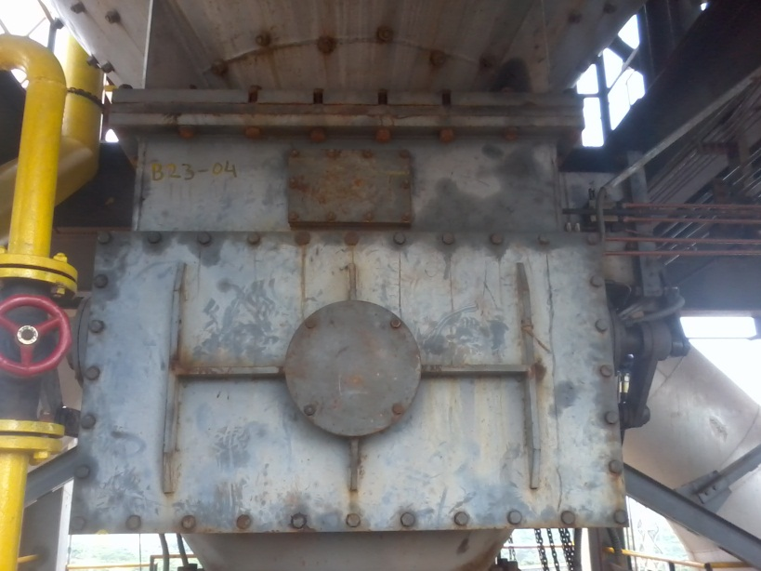

USV manhole door.

|  |
| --- |
| LSV Inspection door flange |

1. Ensure that bottom discharge cone portion is covered with MS plate to prevent any accidental fall of material while dismantling. Also it will protect from furnace heat in case of lower sealing valve. Take help of 20 mm manila rope for easy placement and removal.

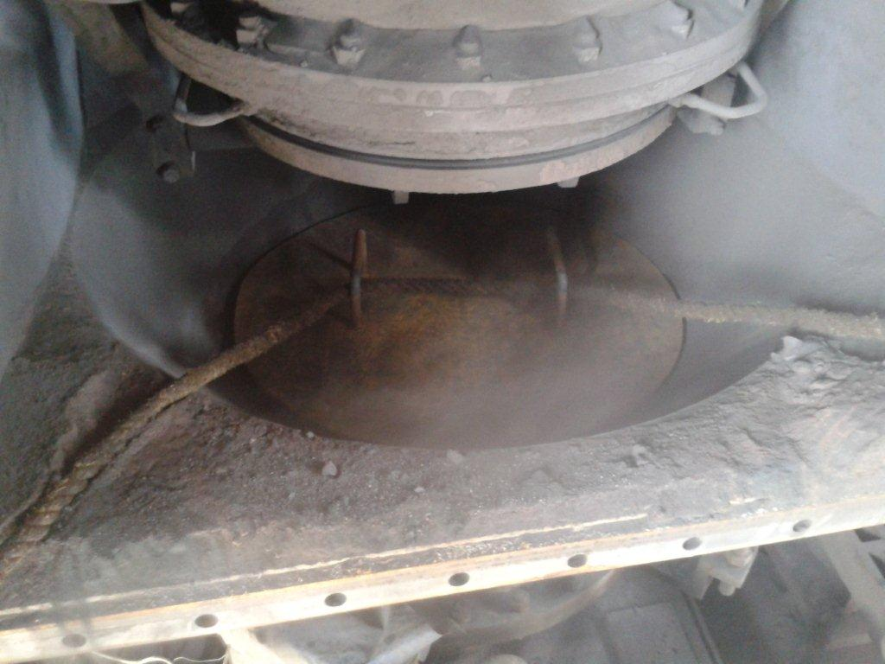

MS plate

1. Now in close co-ordination with control room operation incharge. Fully open the lower sealing valve plate as shown below.

|  |
| --- |
| Lower seal valve in open condition |

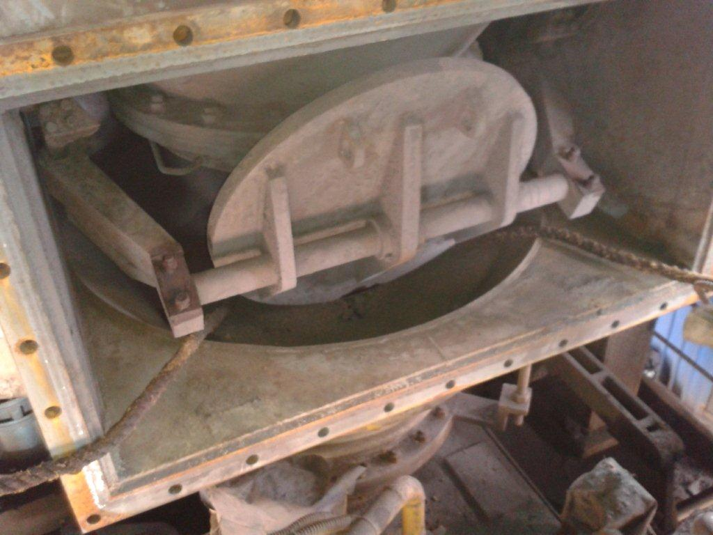

Loosen these bolts(M16X130mm)

1. Take electrical shutdown of power pack and Put mechanical isolation LOTO locks for isolating the inlet & outlet hydraulic line.
2. Connect a 2T chain pulley block to the valve plate for dismantling with wire rope sling Then loosen the 2 side clamp bolts M16X130mm as shown in above photo. Now carefully take out the valve disc plate by help of chain block & keep it aside.

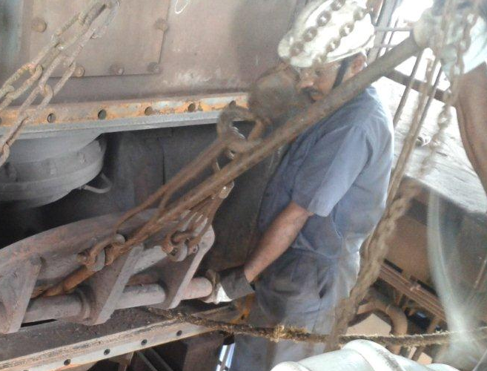

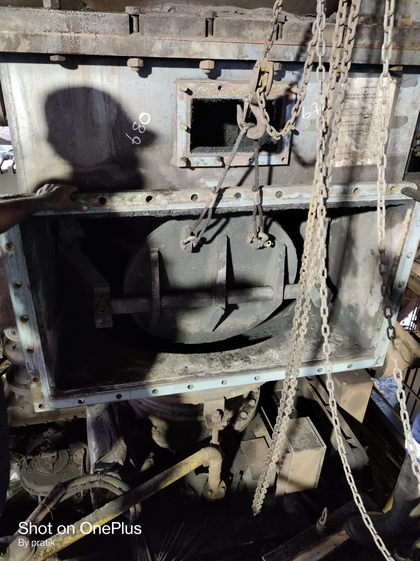

1. Fit the new plate with seal in position and tighten the clamping bolts M16X130mm as shown in above photo.
2. After fitting new plate remove chain block and wire rope sling.
3. Carry out necessary seat adjustment.
4. Clear electrical shut down and remove mechanical isolation LOTO locks of hydraulic line.
5. Take inching trial manually from powerpack by informing control room incharge by standing away from the valve plate.
6. Ensure to remove the MS plate that was provided on top of the cone.
7. Carry out seat leakage test by pouring little quantity of water from the burden flow gate inspection door. Or check the seal by pressurizing burden tank with nitrogen i.e. 1kg/cm2 without opening the burden flow gate inspection door.
8. If operation is found OK then, close the rectangular flange and tighten the flange bolts. Do ensure to inspect the flange seal before it is closed. If found damaged same to be replaced.
9. Close top hatch door
10. Clear the work permit & give clearance.

**Work No 2 : Upper/lower sealing valve hydraulic cylinder replacement**

1. Take clearance from SS to attend the job during running furnace/ planned shutdown by taking work permit.
2. Ensure that valve to be in open condition.
3. Do carry 2nos CO detector and monitor it continuously.
4. Take electrical shutdown of power pack and put mechanical isolation LOTO locks for isolating the inlet & outlet hydraulic line.
5. Slowly loosen the fittings to release the hydraulic oil pressure and collect the oil in empty container. Care should be taken to prevent the oil from falling on the ground. Use bucket to collect the oil from Hoses.
6. Proper marking to be done on hose pipe of inlet and outlet of oil
7. Tie the cylinder with manila rope of minimum 20mm dia.
8. Disconnect the fork pin from the arm.
9. Now loosen the bolts of cylinder mounting bracket & lower it slowly on the platform.
10. Position the spare cylinder & tighten the mounting bolts.
11. Connect the hoses to the cylinder & assemble the cylinder fork with the arm.
12. Clear electrical shut down and remove mechanical isolation LOTO locks of hydraulic line.
13. Keep the hose connection slightly loose and operate manually from powerpack DC valve for removing air from hydraulic line by informing control room in charge.
14. Check for any leakage if any, same to be attended.
15. Perform the house keeping activity as per instruction WI/MAINT/91.
16. Clear work permit & give clearance.

Work No 3 : Upper seal burden stop valve hydraulic cylinder replacement

1. Follow steps 1 to 18 of Work no. 2

Work no 4 : Upper/Lower seal valve plate seal replacement

1. Take clearance from control room in charge for working at furnace top by taking work permit.
2. Do carry 2nos CO detector and monitor it continuously.
3. Remove M10 SS L & key locking bolt (12 nos) of seal locking ring.
4. Once locking bolt removed, used jacking bolt of HT M10 x 50 (4 nos) for removing the seal locking ring. (marking should be done on seal locking ring & valve plate for matching hole while re fitting the locking ring).
5. After removing locking ring remove the seal by help of screw driver and clean the seal groove properly or do buffing on groves if required.
6. Replace the old seal with new seal (care should be taken that seal tapper surface should be match with grove taper surface)
7. Put the locking ring and put M10 SS L & key locking bolt (12 nos) for locking the seal.
8. Clear the work permit.

Work No 2 : Upper/Lower seal valve plate seal cleaning

1. Take clearance from production SS for working at furnace top by taking work permit.
2. Furnace shutdown to be taken and Top firing to be carried out.
3. Do carry 2nos CO detector and monitor it continuously.
4. Keep valve 50 percent in open condition.
5. Take mechanical isolation.
6. Open the inspection door.
7. Use compressed air by using hose for cleaning all corner edges of valve to clean the stuck matrial near valve so valve can operate smoothly.
8. Close the inspection door
9. Clear mechainical isolation and workpermit.

DO:

* Monitor CO levels continuously.
* Ensure that proper hose keeping is carried out after completion of job
* Ensure to confirm the furnace condition with the control room in charge incase job has to be carried out during running furnace.

DO NOT:

* Proceed to furnace top without been accompanied by at least 2 people.
* Do not carry out the activity while tuyere activity is going on in cast house

**REFERENCES: Operation & Maintenance manual.**

**Amendement Record**

|  |  |  |  |
| --- | --- | --- | --- |
| **Date** | **Manual Section Ref. & Para** | **Brief details of Revision** | **New Rev.** |
|  |  |  |  |
|  |  |  |  |
|  |  |  |  |

|  |  |  |
| --- | --- | --- |
| **Prepared By:**  Area Engineer | **Reviewed & Issued By:**  Management Representative | **Approved By:**  Mechanical Head |
| **Signature:** | **Signature:** | **Signature:** |
| **Review Date: 14.09.2022** | **Review Date: 14.09.2022** | **Review Date: 14.09.2022** |